Bootstrap Assignment:

Q1. What are the advantages of Bootstrap?

Ans. One of the most notable advantages of Bootstrap is its inclusion of major components. Essentials like dropdown menus, navigation bars, forms, and progress bars are pre-designed and ready for use. You don't need to build these elements from scratch; instead, you can simply drop them into your project, saving you valuable time and effort.

Q2. What is a Bootstrap Container, and how does it work?

ANS. Bootstrap Containers are the most basic layout element in Bootstrap. Bootstrap Containers are very essential and basic building blocks of bootstrap that wrap a page’s content. It’s responsible for setting and aligning content within it according to viewport or given device.

How does it work:

The .container class provides a responsive fixed width container

The .container-fluid class provides a full width container, spanning the entire width of the viewport

Q3. What are the default Bootstrap text settings?

ANS. Bootstrap's global default text setting font-size is 14px, with a line-height of 1.428.

Q4. What do you know about the Bootstrap Grid System?

ANS. Bootstrap’s grid system uses a series of containers, rows, and columns to layout and align content. It’s built with flexbox and is fully responsive.

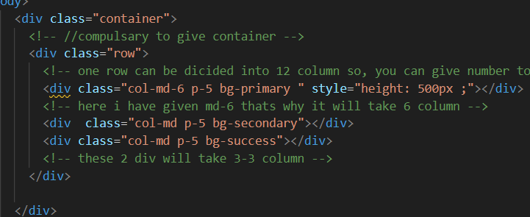

Q5. What is the difference between Bootstrap 4 and Bootstrap 5

ANS.

| BASIS OF | BOOTSTRAP 4 | BOOTSTRAP 5 |
| --- | --- | --- |
| Grid System | It has 5 tier (xs, sm, md, lg, xl). | It has 6 tier (xs, sm, md, lg, xl, xxl). |
| Color | It has limited colors. | Extra colors added with the looks, A card improved color palette. there are various shades available to choose. |
| Jquery | It has jquery and all related plugins. | Jquery is removed and switched to vanilla JS with some working plugins |
| Internet Explorer | Bootstrap 4 supports both IE 10 and 11. | Bootstrap 5 doesn’t support IE 10 and 11. |
| Form elements | Radio buttons, checkboxes have different look in different OS and browsers. The form uses whatever default browsers provide. | The look of form elements will not change, on different OS or browser. The forms can be customized and form controls can be added, they would not depend on browser. |
| Bootstrap Icons | Bootstrap 4 doesn’t have its own SVG icons, we have to use font-awesome for icons. | Bootstrap 5 have its own SVG icons |

Q6. What is a Button Group, and what is the class for a basic Button

Group?

ANS. Button Groups” in [Bootstrap](https://www.geeksforgeeks.org/bootstrap/) is a class of name “btn-group” which is used to create a series of buttons in groups (without spaces) vertically or horizontally.

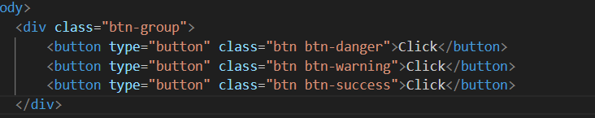

Q7. How can you use Bootstrap to make thumbnails?

ANS. you can use the .img-thumbnail class on an <img> element. This class adds padding, a border, and rounded corners to create a thumbnail-style image.

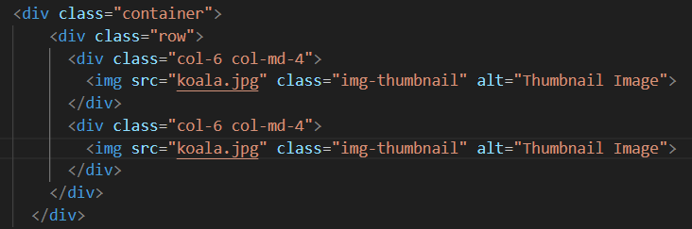

Q8. In Bootstrap 4, what is flexbox?

ANS. The Flexible Box Layout Module, makes it easier to design flexible responsive layout structure without using float or positioning.

Q9. How can one create an alert in Bootstrap?

ANS.

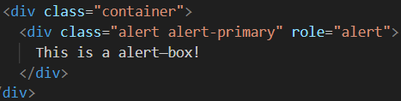

Q10. What is a bootstrap card and how would you create one?

